**Assignment-1**

**Github :** https://github.com/PravalikaMedasani/MLproject.git

**1. Numpy:**

a. Using NumPy create random vector of size 15 having only Integers in the range 1-20.

1. Reshape the array to 3 by 5
2. Print array shape.

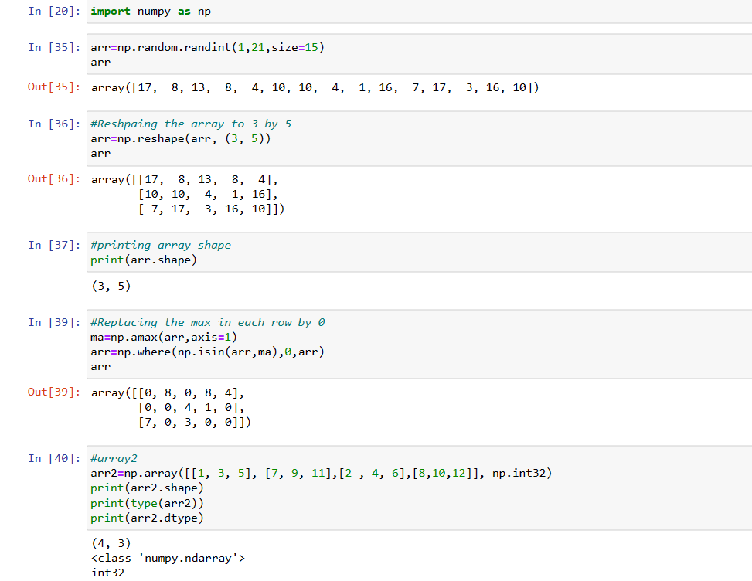

3. Replace the max in each row by 0 Create a 2-dimensional array of size 4 x 3 (composed of 4-byte integer elements), also print the shape, type and data type of the array. 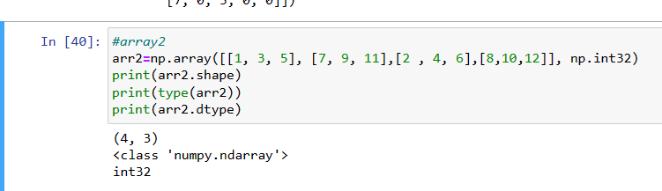

b. Write a program to compute the eigenvalues and right eigenvectors of a given square array given below: [[ 3 -2]

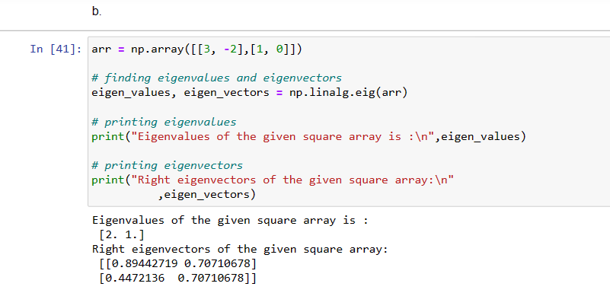

[ 1 0]] c. Compute the sum of the diagonal element of a given array. [[0 1 2] [3 4 5]]

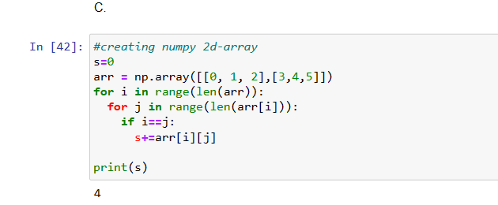

d. Write a NumPy program to create a new shape to an array without changing its data. Reshape 3x2: [[1 2] [3 4] [5 6]] Reshape 2x3: [[1 2 3] [4 5 6]] 2.

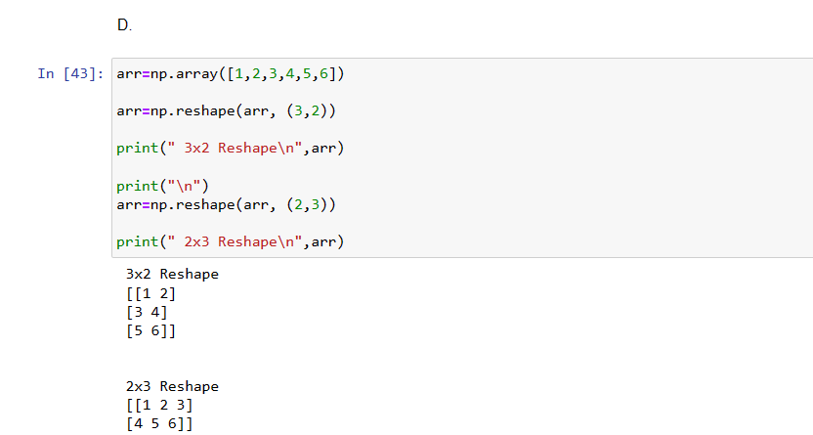**Matplotlib**

1. Write a Python programming to create a below chart of the popularity of programming Languages.

2. Sample data: Programming languages: Java, Python, PHP, JavaScript, C#, C++ Popularity: 22.2, 17.6, 8.8, 8, 7.7, 6.7

